**A Transition from Brick-and-Mortar to Online Stores and Its Role in Shifts in Consumer Buying Patterns**

**Table of Contents**

Chapter 1: Literature Review 4

1.1. Introduction 4

1.2. The Emerging Trend of Online Shopping 4

1.3. Barriers to the Adoption of E-Commerce by Car Retailers 6

1.4. The Effect of Psychological Factors on Car Consumers’ Purchasing Behaviour 9

1.5. Methodology 11

1.6. Summary 13

Chapter 2: Market Study 14

2.1. Introduction 14

2.2. Response Rate and Respondent Profile 14

2.3. Psychological Factors Affecting Consumer Buying Patterns 16

2.4. The Relationship between Psychological Factors and Consumer Behaviour 25

2.5. Limitations 29

2.6. Recommendations 30

2.7. Summary 31

References 32

Appendix A 37

Appendix B 40

Appendix C 43

**List of Figures**

Figure 1: How Old Are You? (%) 15

Figure 2: How Frequently Do You Use the Internet to Search for Car-Related Information? (%) 16

Figure 3: Online Car Retailers Provide Me with a Sufficient Level of Security (%) 17

Figure 4: I Place Great Trust in Car Retailers Operating Online (%) 18

Figure 5: Online Car Retailers Promptly Respond to My Queries and Questions (%) 19

Figure 6: I Can Easily Use My Computer/Mobile Devices to Get Access to the Internet and Make Purchases Online (%) 20

Figure 7: I Have Considerable Experience in Purchasing Online (%) 21

Figure 8: The Level of Online Shopping Convenience Is High (%) 22

Figure 9: Online Shopping Activity Is Pleasant and Exiting (%) 23

Figure 10: Online Car Retailers’ Web Sites Have a Highly Attractive Design (%) 24

Figure 11: I Can Easily Navigate through Online Car Retailers’ Web Sites (%) 25

**List of Tables**

Table 1: Psychological Factors and Purchase Frequency (Linear Regression) 26

Table 2: Psychological Factors and Information Search (Linear Regression) 27

Chapter 1: Literature Review

1.1. Introduction

The purpose of the literature review chapter is to survey and critically analyse the most relevant scholarly and empirical literature on consumer buying patterns (Riaz and Raman, 2015, p. 1). This chapter is based on the main research aim, which is to investigate how a transition from brick-and-mortar to online car sellers has affected consumer buying patterns in the Qatari automotive industry. The literature review chapter consists of six structured subsections, namely introduction, the emerging trend of online shopping, barriers to the adoption of e-commerce by car retailers, the effect of psychological factors on car consumers’ purchasing behaviour, methodology and summary.

1.2. The Emerging Trend of Online Shopping

Online shopping is an accelerating trend in the retail economy of today in both developed and developing countries (Riaz and Raman, 2015, p. 1). Statistics demonstrate that online shopping is a growing business around the world, with more than 50% of all internet users having bought products and services online in 2015 (Statista, 2016a, p. 1). At the same time, it cannot be stated that this rate applies to all countries. For instance, in 2015, the People’s Republic of China was the country where the majority of active internet users had purchased a product or service online within the previous month (Statista, 2016c, p. 1). Qatar is among the countries that demonstrate a significant growth in online shopping. In accordance with the study carried out by Master Card (2016, p. 1), around half of those surveyed made at least one online purchase in 2013. Therefore, Qatar’s citizens are increasingly going online for their shopping needs.

Online retailers can be attributed to multi-channel retailing that is actively used by organisations, including those operating in the automotive industry to get access to a wider market (Wu, 2003, p. 37). In comparison with traditional brick-and-mortar shops, online stores provide their owners with great advantages due to the growing popularity of the internet with consumers (Rezaei et al., 2014, p. 390). Online shops provide a very flexible way to sell services and products since companies cut their costs on logistics, warehousing and rent (AlGhamdi et al., 2011, p. 5). From the consumer perspective, online shopping is perceived to be more convenient since almost every product or service can be purchased just by clicking on several keys on their mobile device or personal computer (Zhou et al., 2007, p. 41). It should be critically remarked, however, that online retailing is associated with certain limitations and downsides such as security issues, which should also be considered (Almousa, 2013, p. 65).

In accordance with Demangeot and Broderick (2007, p. 878), the transition from brick-and-mortar to online retailing is explained by the fact that online shopping is more efficient in addressing consumer needs and wants. Online shopping allows consumers to gain knowledge about a certain brand or product, its quality, process, specifications and availability in a fast and easy way (Merrilees and Fry, 2003, p. 123). As a result, the transition from offline to online shopping has allowed consumers to make more intelligent purchasing decisions. The existing body of literature implies that the buyer’s response to external marketing stimuli is a result of a rational decision process, in which the problem is recognised by the buyer (Liu and Forsythe, 2010, p. 97). At the same time, not all purchasing decisions are rational and conscious (Zhou et al., 2007, p. 41). This statement implies that although online shopping provides consumers with better access to product information, buyer characteristics should also be taken into consideration. These characteristics are discussed in detail in the following sections of this literature review.

In addition to buyer characteristics, the situational factors, which lead to consumers’ willingness to participate in online shopping, can also explain the transition from brick-and-mortar to online stores (Riaz and Raman, 2015, p. 1). In their study, Demangeot and Broderick (2007, p. 878) reported that the reason most buyers like to purchase goods and services online was due to a high level of accessibility as well as great convenience. Shopping online saves consumers the efforts of travelling and spending additional time resources (AlGhamdi et al., 2011, p. 5). Furthermore, the internet allows for making purchases during the 24 hours a day (Riaz and Raman, 2015, p. 1). Therefore, the transition from offline to online stores has allowed retailers to overcome the time limitation as well as the immobility limitation. The point is that not all consumers are able to go out shopping because of long working hours, a physical disability or a considerable distance to the nearest retailer (Nazir et al., 2012, p. 486).

Although online shopping is more convenient, it lags behind traditional offline shopping in certain parameters. For instance, experiences are commonly cited as an important part of shopping and consuming (Liu and Forsythe, 2010, p. 97). The world is now in the state of transition from service economy to experience economy (Sinha and Kim, 2012, p. 46). Consumers are not always looking to purchase a product, but also desire to get pleasure from their shopping experiences. In the traditional shopping environment, memorable experiences are created by means of a wide range of atmospherics such as music, colour schemes, interior, lighting and ambience. At the same time, the environment in online shopping is limited to a much narrower range of atmospherics. Hence, it is impossible to use all the senses to perceive online shopping experiences, which is a limitation comparing to offline shopping. Zhou et al. (2007, p. 41) reported that navigating web sites was another factor that could prevent consumers from making frequent online purchases. Users who experience difficulties with navigating web sites were identified by Monsuwe et al. (2004, p. 102) to frequently complain on refunds, return policies and billing problems.

In 2009, around 4% of all global retail sales were online. In 2011, this trend accelerated to more than 11% (Singh, 2014, p. 1). In certain industries such as entertainment and publishing, retailers collect more than half of their revenues online (Alrawi and Sabry, 2009, p. 509). However, the automotive industry lags behind its ‘counterparts’. In accordance with the recent market studies, it is forecasted that about 5% of all cars in the world are going to be sold online by 2020 (Frost & Sullivan, 2016a, p. 1; Frost & Sullivan, 2016b, p. 1). Some major market players like Ford and Tesla already sell their cars in the online environment (Ford, 2016, p. 1). Nevertheless, the inability of online stores to create a buying experience similar to an offline shop as well as the lack of consumers’ knowledge may significantly hamper the transition from brick-and-mortar to online stores in the automotive industry (Sinha and Kim, 2012, p. 46).

1.3. Barriers to the Adoption of E-Commerce by Car Retailers

The emergence of information technology has provided profit-driven organisations with access to more effective marketing communications channels (Demangeot and Broderick, 2007, p. 878). Alternatively to traditional marketing tools such as TV, radio and printed materials, more advanced instruments (e.g. social networking services and mobile applications) allow for much easier access to a target population at lower costs and expenditures (Monsuwe et al., 2004, p. 102). Furthermore, the growing popularity of social media with consumers is another factor that adds to their attractiveness as marketing tools. For example, Facebook has more than 1.5 billion monthly active users (Statista, 2016d, p. 1). As a result, there has been a clear trend towards shifting from brick-and-mortar retailing to e-commerce (Colla and Lapoule, 2012, p. 824). However, the degree to which this shift has proved to be successful in the retail industry is subject to heated debate among marketing scholars and researchers (Monsuwe et al., 2004, p. 102; AlGhamdi et al., 2011, p. 1).

In their empirical investigation, Nazir et al. (2012, p. 486) attempted to assess the extent to which the transition from brick-and-mortar to online business strategy was effective and successful in the retail industry. The researchers arrived at the conclusion that the effectiveness of this transition was hampered by a wide range of external and internal factors (Nazir et al., 2012, p. 486). For example, the lack of perceived security, customers’ previous experience and inability to try out products can be attributed to external barriers to the transition from brick-and-mortar to online stores (Colla and Lapoule, 2012, p. 824). At the same time, poor customer service, the lack of expertise and resources and vague product description are usually cited as the most formidable internal barriers to this transition. The identified barriers are also applicable to the automotive industry since many car retailers have recently shifted their business operations online (Solomon et al., 2010, p. 67).

An attempt to examine the factors, which affected the diffusion and adoption of e-commerce by retailing organisations was made by AlGhamdi et al. (2011, p. 1). Similarly to this project, the researchers collected primary data from around 150 consumers and processed it using both graphical and statistical methods of analysis. AlGhamdi et al. (2011, p. 1) found that the consumers’ attitudes, preferences and perceptions had the strongest negative effect on the transition of retailers from a traditional brick-and-mortar strategy to online. It should be critically remarked, however, that the researchers were focused on the consumers who belonged to an older generation, which can be viewed as a limitation. As argued by Liu and Forsythe (2010, p. 97), young consumers use social media and mobile technology more actively. In addition, the extent to which the older generation of consumers adopt information technology, including the internet, social networking services and mobile applications is highly limited comparing to younger persons (Sinha and Kim, 2012, p. 46). Therefore, the inclusion of younger individuals in the sample could have allowed AlGhamdi et al. (2011, p. 1) to arrive at more interesting and comprehensive conclusions.

Another interesting study was conducted by Alrawi and Sabry (2009, p. 509). Similarly to AlGhamdi et al. (2011, p. 1), Alrawi and Sabry (2009, p. 509) discovered that the lack of understanding as well as a high level of resistance to new technology among consumers was a considerable factor that limited the effectiveness of e-commerce in the retail industry. These findings can be explained by the fact that consumers are not able to try out a product in the online environment since they do not have direct access to this good (Solomon et al., 2010, p. 67). Furthermore, consumers may avoid purchasing online because of security issues. This statement is especially relevant to the automotive industry since cars can be attributed to highly expensive products. The findings produced by Alrawi and Sabry (2009, p. 509) imply that consumer preferences, attitudes, habits, perceptions, resistance to new technology and the lack of understanding are among the most considerable factors, which hamper the adoption of e-commerce in the automotive industry. Nevertheless, this assumption should be empirically tested to identify whether these factors are also relevant to the Qatari car industry.

Considering the outcomes of this literature review section, it is relevant to assume that the lack of perceived security and trust, poor customer service, inability to try out products and consumers’ previous purchasing experience severely hamper the adoption of e-commerce in the Qatari automotive industry (Solomon et al., 2010, p. 67). The relevance of these barriers to the context of the Qatari car industry is tested in the course of this knowledge-based project. By discovering the most formidable barriers to the adoption of e-commerce by car retailers, it is possible to identify how the transition from brick-and-mortar to online car sellers has affected consumer buying patterns in the Qatari automotive industry.

1.4. The Effect of Psychological Factors on Car Consumers’ Purchasing Behaviour

This dissertation attempts to identify specific preferences and attitudes, which shape and form car consumers’ buying patterns. Chang et al. (2005, p. 543) offered a comprehensive classification of consumers’ shopping activity in the online environment. In accordance with the researchers, all variables, which drive this activity, can be divided into three broad categories, namely the characteristics of the web sale channel, product characteristics and consumer-related characteristics (Chang et al., 2005, p. 543). The first group of factors consists of a wide range of web sale channel characteristics such as shopping experience, service quality, advantage, trust and risk (Demangeot and Broderick, 2007, p. 878). The next group of variables consists of risk reduction measures, web site features (e.g. design, the ease of use, navigation and attractiveness) and product and service aspects. The third category consists of consumer-related characteristics such as shopping orientation, perceptions, knowledge and attitudes (Tan and Thoen, 2001, p. 61). The significance of the model suggested by Chang et al. (2005, p. 543) is that it considers both external and internal factors that influence consumer buying patterns. Nevertheless, there are many additional factors, which were not taken into consideration by Chang et al. (2005, p. 543). For example, marketing stimuli (i.e. price, promotion, place and product) and post purchase evaluation also have a strong impact on consumers’ buying behaviour (Uzun and Poturak, 2014, p. 163).

Even though all three categories of Chang’s et al. (2005, p. 543) framework are considered to have a strong effect on consumers’ purchasing behaviour, Vasquez and Xu (2009, p. 408) believed that the mentioned consumer-related characteristics played the most essential role in their buying patterns. It is relevant to focus on this group of characteristics (e.g. motives, perceptions, attitudes and knowledge) and empirically test their impact on consumers’ purchasing behaviour in the online environment in the Qatari automotive industry. In accordance with Rezaei et al. (2014, p. 390), the buyer’s response to the previously mentioned marketing and environmental stimuli is a result of a rational decision process. This statement is consistent with Brosekhan et al. (2002, p. 8), according to whom the decision process, which is a part of the black box model, is conscious and rational. Nevertheless, many consumers do not make buying decisions in awareness of a determined problem (Liu and Forsythe, 2010, p. 97).

Although the black box model provides an insight into consumer purchasing behaviour, the extent to which this theoretical model is applicable to the online environment remains underexplored (Colla and Lapoule, 2012, p. 824). Offline consumer purchasing behaviour models have been in existence since the late 1960s (Uzun and Poturak, 2014, p. 163). At the same time, online models have been in development only since the 1990s (Chang et al., 2005, p. 543). A relevant investigation into the factors that affected the online purchasing behaviour was carried out by Vasquez and Xu (2009, p. 408). The researchers arrived at the conclusion that security perceptions, the lack of trust and poor product information were among the most significant factors, which prevented consumers from purchasing goods and services in the online environment (Vasquez and Xu, 2009, p. 408).

The key limitation Vasquez and Xu’s (2009, p. 408) study is that the researchers were focused exclusively on the UK, which can be viewed as a limitation. Although the UK is a highly developed country, British consumers are still maturing in their online behaviour (Statista, 2016a, p. 1). Therefore, the generalisability of Vasquez and Xu’s (2009, p. 408) project to Qatar is limited. In 2015, there were around 46 million internet users in the UK, while there were only 2.1 million internet users in Qatar (ILS, 2016, p. 1; Statista, 2016b, p. 1). Nevertheless, the total population of Qatar is equal to 2.3 million users, while the UK has a population of 64 million users (The World Bank, 2016, p. 1). Therefore, around 92% of Qatar’s population actively use the internet. In the UK, this indicator is equal to 70%. However, these results do not allow for stating that Qatari consumers use the internet as a means of shopping more actively comparing to British consumers.

The issue of consumer behaviour in the online environment was investigated by Sinha and Kim (2012, p. 46). The researchers attempted to identify factors affecting consumers’ attitudes towards online shopping. It was concluded by Sinha and Kim (2012, p. 46) that perceived risks such as financial risk, product risk and convenience risk were the most important factors influencing consumers’ attitudes towards online shopping, which, in turn, shaped and formed their online shopping behaviour. In addition to the perceived risks, Uzun and Poturak (2014, p. 163) found that service quality and infrastructure elements such as return policy and delivery concerns also impacted the attitudes of online shoppers. Although Sinha and Kim (2012, p. 46) shed insights on online retailing in developing countries as well as the factors influencing consumers’ online purchasing patterns, their study was limited to active internet users. As a result, their empirical outcomes may not be generalisable to non-active internet users (Nazir et al., 2012, p. 486). The inclusion of less experienced internet users in the sample could have allowed for arriving at more comprehensive conclusions.

The limitations of Sinha and Kim’s (2012, p. 46) study were overcome by Uzun and Poturak (2014, p. 163) who examined specific factors affecting e-consumers. Alternatively to Sinha and Kim (2012, p. 46), Uzun and Poturak (2014, p. 163) gathered primary data from internet users regardless of their previous online shopping experience. The results demonstrated that there was a link between perceived risk and consumers’ online purchasing patterns. Furthermore, Uzun and Poturak (2014, p. 163) found that online shoppers’ purchasing behaviour depended heavily on web design and delivery time. These findings correlate closely with those achieved by Uygun et al. (2011, p. 373) according to whom the psychological factors such as motives, perceptions, knowledge and attitudes have a strong impact on consumers’ intention to purchase online. Uzun and Poturak’s (2014, p. 163) study is also in keeping with Almousa (2013, p. 65) who reported that service aspects and web site features, including navigation, design and attractiveness play an important role in consumer purchasing behaviour in the online environment.

1.5. Methodology

Since this dissertation explores how the transition from brick-and-mortar retailers is relevant to the future of marketing, the methodology is knowledge-based (Zikmund et al., 2003, p. 76). A mixed method approach has been adopted since this study is interested in the collection of qualitative and quantitative data. The main advantage of this approach is that the researcher can get access to multiple data sources and triangulate them in order to validate the research outcomes (Ghauri and Gronhaug, 2005, p. 75). At the same time, the adoption of the mixed method requires highly developed analysis and synthesis skills and competencies (Easterby-Smith et al., 2008, p. 97). Otherwise, the analysis process could result in the production of subjective and biased outcomes.

A survey strategy has been selected for the purpose of this study to identify how the transition of car selects to the online environment has impacted consumer behaviour in the Qatari automotive industry (Saunders et al., 2009, p. 144). This choice is justified by the need to build cause-and-effect relationships and identify specific characteristics, which affect car consumers’ purchasing behaviour. According to Tashakkori and Teddlie (2003, p. 72), surveys are much more cost-efficient in comparison with alternative research strategies such as observations or experiments. Limited time and financial resources have contributed to the researcher’s decision to employ the survey strategy. However, the data collected by means of this strategy is considered to be narrow-ranged and less diversified comparing to the mentioned alternative strategies (Saunders et al., 2009, p. 144).

The survey strategy incorporates two major data collection techniques, namely questionnaires and interviews (Bryman and Bell, 2010, p. 102). Self-administered questionnaires have been chosen as the main source of evidence since they provide the researcher with an opportunity for getting access to a sizeable population of car consumers in Qatar who prefer making purchases online (Tashakkori and Teddlie, 2003, p. 72). The selection of self-administered questionnaires is also justified by the need to establish cause-and-effect links between the previously discussed psychological factors and customer purchasing behaviour.

Alternatively to open-ended interviews, self-administered questionnaires are focused on the collection of quantitative data, which can be easily processed using statistical analysis instruments and tools (Bryman and Bell, 2010, p. 94). By employing self-administered questionnaires, the researcher is capable of building statistical links between dependent and independent variables and identifying how the emergence of e-commerce has impacted consumer behaviour in the Qatari automotive industry. However, this data collection technique is considered as subjective and misleading (Saunders et al., 2009, p. 144). This limitation is explained by the fact that questionnaire survey participants’ responses may be subjective and biased and, hence, threaten the validity and reliability of the produced research outcomes (Bryman and Bell, 2010, p. 94).

Quantitative data was gathered by means of self-administered questionnaires, which were distributed among 300 Qatari automotive consumers who prefer buying products and services online and searching for car-related information on the internet. Potential respondents were contacted via the most popular social networking services, including Facebook and Twitter and asked to fill in a questionnaire on SurveyMonkey.com. The actual response rate is reported in the following chapter of this paper. The questionnaire, which can be found in Appendix A, offered respondents to identify the most important psychological factors that could impact their consumer behaviour.

In turn, qualitative data was obtained from 10 Qatari consumers with the help of open-ended interviews. During the data collection process, the interviewees were asked about their attitudes towards and perceptions of online purchasing (Nandagopal et al., 2009, p. 103). The non-probability convenience sampling technique was employed to get access to the most easily contacted Qatari consumers. Excel was used to construct a set of raw data and build graphs and charts. In turn, Statistical Package for the Social Sciences (SPSS) was employed to process the gathered data statistically and establish cause-and-effect links between dependent and independent variables (Carver and Nash, 2011, p. 46; Bryman and Cramar, 2011, 78).

1.6. Summary

It can be summarised that online shopping is a growing trend in the retail economy in both developed and developing countries (Rezaei et al., 2014, p. 390). It is possible to explain the transition from brick-and-mortar to online retailing by the fact that online shopping is more efficient in addressing consumer needs and wants. At the same time, the lack of perceived security and trust, poor customer service, inability to try out products and consumers’ previous purchasing experience can severely hamper the adoption of e-commerce in the automotive industry (Nazir et al., 2012, p. 486). It is also relevant to summarise that psychological characteristics such as motives, perceptions, attitudes and knowledge have a strong impact on consumers’ purchasing behaviour in the online environment (Uzun and Poturak, 2014, p. 163).

Chapter 2: Market Study

2.1. Introduction

This chapter analyses, presents and interprets the primary data collected from Qatari automotive consumers. According to the methodology section, both open-ended interviews and self-administered questionnaires were used as the key sources of evidence (Saunders et al., 2009, p. 144). Quantitative data is processed graphically and statistically in order to investigate how a transition from brick-and-mortar to online car sellers has affected consumer buying patterns in the Qatari automotive industry. In turn, content analysis methods are used to analyse qualitative data. The market study section consists of seven structured subsections, namely introduction, response rate and respondent profile, psychological factors affecting consumer buyer patterns, the relationship between psychological factors and consumer behaviour, limitations, recommendations and summary.

2.2. Response Rate and Respondent Profile

This section analyses and interprets the background data gathered from Qatari consumers. Although the analysis of this data does not contribute to the achievement of the chief aim, it allows the researcher to construct detailed respondent profiles (Bryman and Bell, 2010, p. 91). This action is beneficial to the validity and reliability of this project since only those individuals who have considerable knowledge of and experience in purchasing online could be included in the sample (Zikmund et al., 2003, p. 120). According to the methodology section, 300 questionnaires were distributed among potential respondents. In turn, 153 questionnaires were returned to the researcher. 27 questionnaires were excluded from the sample due to missing data. The remaining 126 questionnaires were used for the purpose of this study. Taking into account the number of the questionnaires used in this study, it is relevant to state that the response rate is 42%.

In accordance with Zhou et al. (2007, p. 45), the majority of social media users are young individuals between 18 and 30 years old. This statement is partly consistent with the outcomes of the graphical analysis, the results of which are presented by means of the chart below.

Figure 1: How Old Are You? (%)

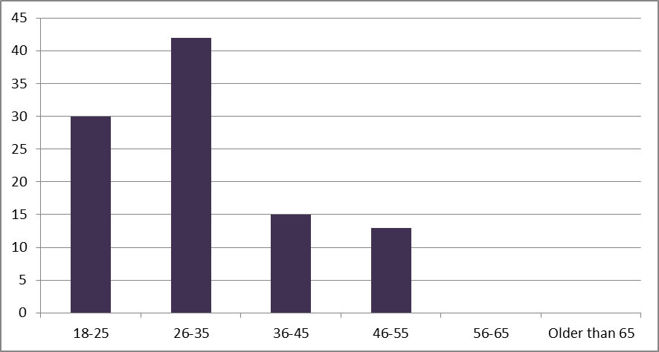

The majority or 42% of the sample reported they were between 26 and 35 years. Almost one third or 30% of the respondents indicated they belonged to the ‘18-25’ age group. The individuals who asserted they were between 36 and 45 years accounted for 15% of the sample. The remaining 13% of the participants were between 46 and 55 years. None of the Qatari consumers reported they were older than 55 years. Hence, individuals between 18 and 55 years participated in the questionnaire survey. The degree to which the participants actively use the internet to search for car-related information is shown as follows.

Figure 2: How Frequently Do You Use the Internet to Search for Car-Related Information? (%)

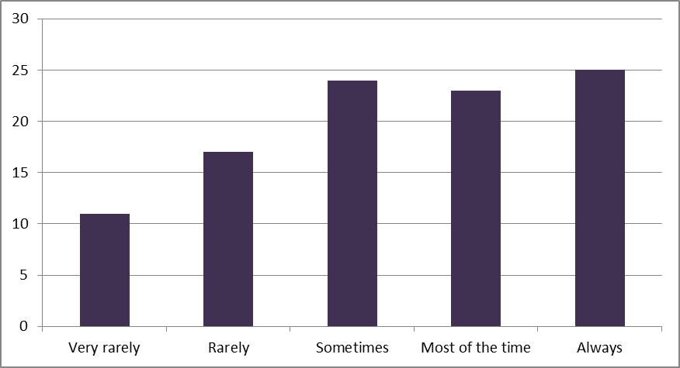

The respondents who selected the ‘most of the time’ and ‘always’ response options accounted for 23% and 25% of the sample, respectively. On the contrary, in total, 28% of the individuals reported that they rarely or very rarely used the internet to search for car-related information. The remaining 24% of the Qatari consumers indicated they sometimes used the internet for this purpose. These outcomes imply that the majority of those surveyed use the internet to search for car-related information quite frequently. Further analysis demonstrates that most individuals purchase online at least once per week (see Appendix B). At the same time, more than half or 52% of the participants reported they had never bought a car using the internet (see Appendix B).

2.3. Psychological Factors Affecting Consumer Buying Patterns

In accordance with the literature review chapter, security issues are among the key factors that impact the adoption of e-commerce in the automotive industry (Alrawi and Sabry, 2009, p. 509). The extent to which the research participants perceive online car retailers to provide them with a high level of security is presented as follows.

Figure 3: Online Car Retailers Provide Me with a Sufficient Level of Security (%)

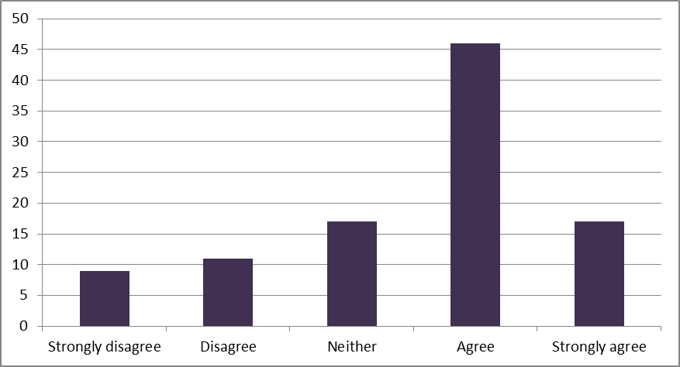

The overwhelming majority or 47% of the Qatari car consumers agreed that online car retailers provided them with a sufficient level of security. 17% of those who returned their questionnaire strongly agreed with this statement. On the contrary, the participants who either disagreed or strongly disagreed that the level of security provided to them by online car retailers was sufficient accounted for 11% and 9% of the sample, respectively. The remaining 17% of the Qatari consumers responded neutrally to this statement. Hence, the security level of online car retailers is perceived by most respondents as high.

Perceived trust is another factor that has an impact on the adoption of e-commerce in the retail industry (Solomon et al., 2010, p. 67). The following histogram demonstrates the participants’ perceived trust in Qatari online car retailers.

Figure 4: I Place Great Trust in Car Retailers Operating Online (%)

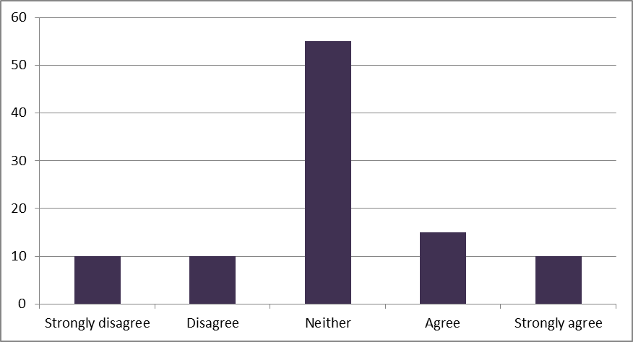

More than half or 55% of those who returned their questionnaire neither agreed nor disagreed that they placed great trust in car retailers operating online and provided the researcher with neutral answers. In total, only 25% of the Qatari consumers either agreed or strongly agreed that they trusted online car retailers. On the contrary, the participants who either disagreed or strongly disagreed with their counterparts totalled 20% of the sample. The analysis outcomes indicate that the extent to which the respondents perceive online car retailers as reliable is limited.

As argued by Solomon et al. (2010, p. 67), poor customer service was a formidable barrier to the transition from brick-and-mortar to online stores. The extent to which the quality of customer service provided by Qatari online car retailers is perceived by the respondents as high is presented as follows.

Figure 5: Online Car Retailers Promptly Respond to My Queries and Questions (%)

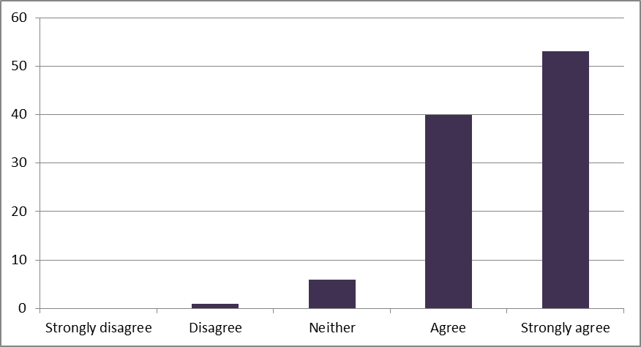

The overall response to this question, as demonstrated by the chart above, was very positive. Over half or 53% of the Qatari consumers strongly agreed that online car retailers promptly responded to their queries and questions. As much as 40% of those who returned their questionnaire also agreed with this statement. On the downside, the participants who indicated that online car retailers took much time to respond to their questions totalled only 1% of the sample. The remaining 6% of the Qatari consumers selected the ‘Neither’ response variant. These outcomes demonstrate that the level of customer service provided by online car retailers to consumers is perceived as high.

According to Demangeot and Broderick (2007, p. 878), the ease of use is an important variable of shopping activity in the online environment. The following histogram demonstrates the extent to which the respondents can get access to the internet and make online purchases.

Figure 6: I Can Easily Use My Computer/Mobile Devices to Get Access to the Internet and Make Purchases Online (%)

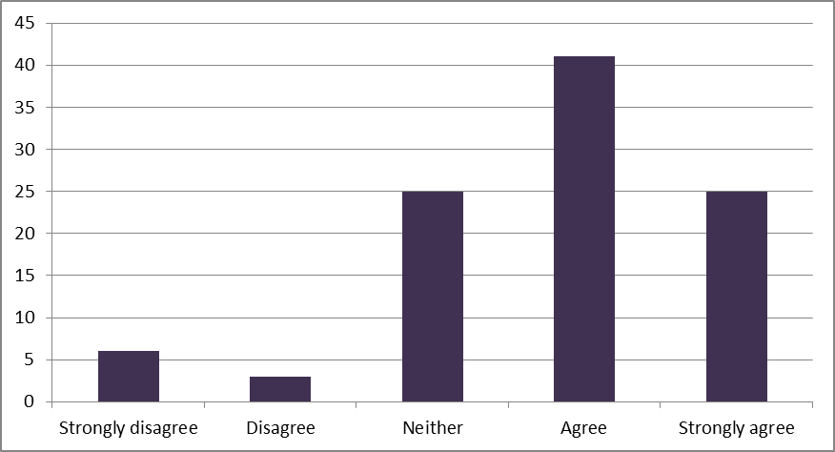

More than one third or 41% of those surveyed agreed they could easily use their computer or mobile devices to get access to the internet and make purchases online. The participants who strongly agreed with this statement accounted for one fourth or 25% of the sample. On the contrary, in total, only 9% of the Qatari consumers indicated that their access to the online environment was limited. Finally, 25% of the individuals neither agreed nor disagreed with their peers and gave neutral responses to this statement. The graphical analysis outcomes suggest that the popularity of online shopping as a way of making purchases is high among the participants.

Customers’ poor experience was identified by Colla and Lapoule (2012, p. 824) as an external barrier to the transition from brick-and-mortar to online stores. The following chart shows the extent to which the survey participants are experienced in purchasing online.

Figure 7: I Have Considerable Experience in Purchasing Online (%)

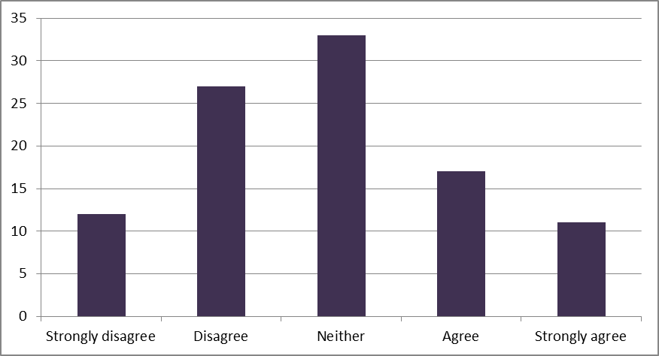

The individual responses to this question were mixed. On the one hand, the participants who either agreed or strongly agreed they had considerable experience in making purchases online totalled 28% of the sample. On the other hand, in total, 39% of those who retuned their questionnaire indicated their experience in purchasing online was not considerable. Finally, one third or 33% of the Qatari consumers responded neutrally to this question. Therefore, most respondents do not have long experience in online shopping. According to Colla and Lapoule (2012, p. 824), this factor can have a negative impact on consumes’ purchasing behaviour in the online environment. This statement is tested in the following section of the market study chapter.

According to the literature review, perceived convenience risk is among the most important factors influencing consumers’ attitudes towards online shopping (Sinha and Kim, 2012, p. 46). The level of the perceived convenience of online shopping is presented by means of the following chart.

Figure 8: The Level of Online Shopping Convenience Is High (%)

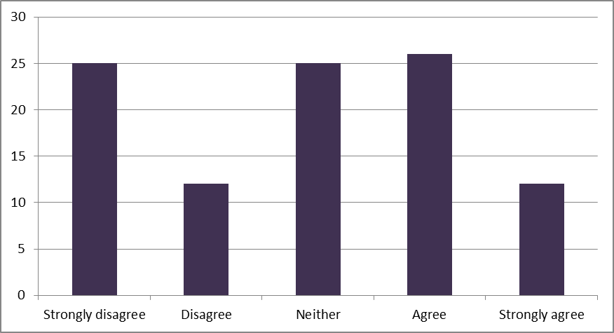

In total, 38% of the survey participants either agreed or strongly agreed the level of online shopping convenience was high. On the contrary, the Qatari consumers who either disagreed or strongly disagreed with their counterparts and indicated that online shopping was associated with convenience risk totalled more than one third or 37% of the sample. Finally, one fourth or 25% of the respondents provided the researcher with neutral responses. These graphical analysis outcomes suggest that the level of perceived online shopping convenience is not considerable among Qatari consumers.

In their study, Sinha and Kim (2012, p. 46) arrived at the conclusion that in addition to making a purchase, consumers might want to get pleasure from their shopping experiences. The degree to which online shopping activity is perceived by the respondents as pleasant and exiting is shown as follows.

Figure 9: Online Shopping Activity Is Pleasant and Exiting (%)

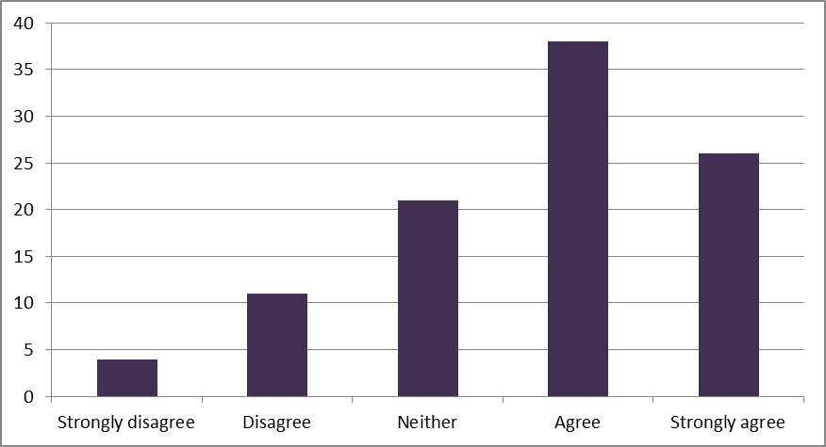

Overall, the response to this question was positive since more than one third or 38% of those surveyed agreed that online shopping activity was pleasant and exiting. Furthermore, 26% of the respondents strongly agreed with this statement. At the same time, the Qatari consumers who indicated that there was nothing pleasant and exiting about online shopping activity totalled 15% of the sample. The remaining 21% of the participants neither agreed nor disagreed with this statement and selected the ‘Neither’ response option. Therefore, online shopping activity is perceived by Qatari consumers as pleasant and exiting.

Web site design, which belongs to the product characteristics group of factors, was identified by Demangeot and Broderick (2007, p. 878) to have a strong impact on the adoption of e-commerce. The following graph shows the extent to which the respondents perceive online car retailers’ web sites as attractive.

Figure 10: Online Car Retailers’ Web Sites Have a Highly Attractive Design (%)

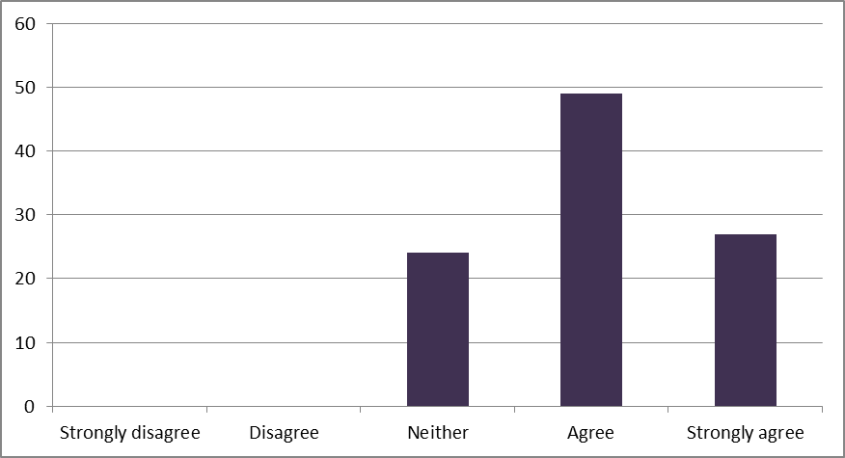

Almost half or 49% of those surveyed agreed that online car retailers’ web sites had a highly attractive design. Furthermore, the survey participants who strongly agreed with their counterparts accounted for 27% of the sample. Around one fourth or 24% of the Qatari consumers provided the researcher with neutral responses. None of the respondents evaluated the design of online car retailers’ web sites as unattractive. Highly attractive and appealing web design may have a positive impact on consumers’ purchasing behaviour in terms of purchase frequency (Almousa, 2013, p. 65). This assumption is tested in the following sections of this chapter.

In accordance with Zhou et al. (2007, p. 41), issues with navigating web sites are an important factor that can prevent consumers from making frequent online purchases. The perceived ease of navigating through online car retailers’ web sites is presented as follows.

Figure 11: I Can Easily Navigate through Online Car Retailers’ Web Sites (%)

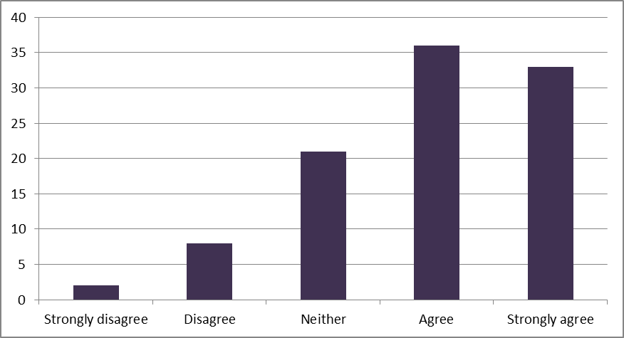

In total, more than two thirds or 69% of the individuals either agreed or strongly agreed they could easily navigate through online car retailers’ web sites. On the downside, only a minority or in total, 10% of the Qatari consumers indicated they experienced difficulties in navigating through the web sites of car retailers in the online environment. Finally, the respondents who gave neutral answers to this question accounted for 21% of the sample. Thus, the majority of those surveyed did not experience difficulties with navigating online car retailers’ web sites.

2.4. The Relationship between Psychological Factors and Consumer Behaviour

The linear regression function was performed in the SPSS software package in order to establish statistically significant links between the previously identified psychological factors and consumer behaviour. The statistical analysis outcomes are presented by means of the following table.

Table 1: Psychological Factors and Purchase Frequency (Linear Regression)

|  |  |  |  |  |  |  |
| --- | --- | --- | --- | --- | --- | --- |
| **Variable** | **Unstandardized Coefficients** | | **t** | **Sig.** | **Collinearity Statistics** | |
| **B** | **Std. Error** | **Tolerance** | **VIF** |
| α | 7.806 | 1.208 | 6.459 | 0.000 |  |  |
| SEC | -0.055 | 0.089 | -0.611 | 0.542 | 0.946 | 1.057 |
| TRU | -0.125 | 0.105 | -1.190 | 0.236 | 0.901 | 1.110 |
| RES | -0.314 | 0.158 | -1.988 | 0.049 | 0.951 | 1.051 |
| ACC | 0.001 | 0.095 | 0.013 | 0.989 | 0.974 | 1.027 |
| EXP | -0.056 | 0.090 | -0.628 | 0.531 | 0.917 | 1.090 |
| CON | -0.340 | 0.075 | -4.512 | 0.000 | 0.949 | 1.054 |
| EXT | -0.010 | 0.097 | -0.108 | 0.914 | 0.911 | 1.098 |
| ATT | -0.094 | 0.143 | -0.657 | 0.512 | 0.963 | 1.038 |
| NAV | -0.161 | 0.098 | -1.630 | 0.106 | 0.974 | 1.026 |

The relationship between the RES and FRE variables is statistically significant at 95% since the Significance (Sig.) of the predictor is equal to 0.049, which is lower than the threshold value of 0.05. B coefficient is negative, meaning the link between the variables is also negative. Therefore, the established relationship can be interpreted as follows: the more promptly online car retailers respond to consumers’ quires and questions, the less frequently they purchase online. These outcomes may demonstrate that high-quality customer service adds to consumers’ confidence and willingness to purchase from an online shop. On the contrary, poor customer service forces Qatari consumers to go to another online store and ask their questions there. As a result, consumers make less frequent purchases online. These findings are in keeping with Solomon et al. (2010, p. 67) who also argued that the lack of customer service was a formidable internal barrier to the transition from brick-and-mortar to online stores.

The table above also demonstrates that CON and FRE form another statistically significant relationship since the Sig. of the independent variable is much lower than the threshold value. Considering negative B coefficient, it is relevant to interpret the established link as follows: the less online shopping is convenient for Qatari consumers, the more frequently they purchase online. These outcomes correlate with the interview survey findings. Interviewee 4 stated that “[the convenience of shopping online] should not be high, because it is easier to fool me online than in person. So not safe” (Appendix C). Therefore, the inconvenience of online shopping is perceived by Qatari consumers as a factor that adds to its attractiveness. Alternatively to this market study, Zhou et al. (2007, p. 41) arrived at the conclusion that the convenience of online shopping was perceived as higher in comparison with more traditional ways of purchasing goods and services. This statement was supported by some interviewees. For example, as reported by Interviewee 10, “I can [make online purchases] before I go to sleep, when I am in bed, when I wake up, when I am in a boring meeting, when my car is breaking down, anytime” (Appendix C).

None of the remaining predictors form any statistically significant link with the independent variable since their Sig. is higher than 0.05, which is the threshold value. The Variance Inflation Factor (VIF), which measures collinearity in the regression model, is within its normal range (n = 5). Hence, the statistical analysis outcomes do not show multicollinearity and none of the predictors should be excluded from the constructed model. The following table demonstrates whether the previously identified psychological factors influence the extent to which the participants actively search for car-related information using the internet.

Table 2: Psychological Factors and Information Search (Linear Regression)

|  |  |  |  |  |  |  |
| --- | --- | --- | --- | --- | --- | --- |
| **Variable** | **Unstandardized Coefficients** | | **t** | **Sig.** | **Collinearity Statistics** | |
| **B** | **Std. Error** | **Tolerance** | **VIF** |
| α | 4.324 | 1.262 | 3.425 | 0.001 |  |  |
| SEC | 0.090 | 0.093 | 0.960 | 0.339 | 0.946 | 1.057 |
| TRU | 0.251 | 0.110 | 2.290 | 0.024 | 0.901 | 1.110 |
| RES | 0.082 | 0.165 | 0.494 | 0.622 | 0.951 | 1.051 |
| ACC | -0.202 | 0.099 | -2.038 | 0.044 | 0.974 | 1.027 |
| EXP | -0.228 | 0.094 | -2.428 | 0.017 | 0.917 | 1.090 |
| CON | -0.106 | 0.079 | -1.352 | 0.179 | 0.949 | 1.054 |
| EXT | 0.067 | 0.101 | 0.662 | 0.510 | 0.911 | 1.098 |
| ATT | -0.099 | 0.150 | -0.662 | 0.509 | 0.963 | 1.038 |
| NAV | -0.033 | 0.103 | -0.317 | 0.752 | 0.974 | 1.026 |

The linear regression analysis findings indicate that there is a statistically significant relationship between the TRU and SEA variables since the Sig. of the predictor is lower than the threshold value and equal to 0.024. Positive B coefficient allows for stating that the link is positive. Hence, the more Qatari consumers trust online car retailers, the more actively they use the internet to search for car-related information. These outcomes are in keeping with Demangeot and Broderick (2007, p. 878) who also arrived at the conclusion that the extent to which consumers trust online stores determined their adoption of e-commerce as well as the use of the internet as a means of making purchases.

Further analysis shows that the participants actively use the internet to search for car-related information since it provides easy access to a wide range of sources. For instance, Interviewee 1 stated that he/she used the internet “because it is really easy to search for it, you can find reviews from clients and users feedback on the cars. Pictures, videos and get all the information you need without going to a showroom” (Appendix C). Interviewee 2 added that “I can find all the brands I may be interested in. Rather than going to each dealer and obtaining the information I need. I can get all the information from one screen for comparison” (Appendix C). These outcomes are consistent with AlGhamdi et al. (2011, p. 5) who reported that shopping online saved consumers the efforts of travelling and spending additional time resources. Hence, the transition from brick-and-mortar to online stores has allowed consumers to search for relevant information in a more convenient and time-efficient manner. At the same time, not all factors mentioned in the literature review chapter predict the extent to which consumers actively use the internet to search for information.

The linear regression outcomes also demonstrate that the Sig. of the ACC variable is equal to 0.044, which is lower than the threshold value. Considering negative B coefficient, it is possible to interpret the statistical relationship as follows: the more consumers use their computers and mobile devices to get access to the internet, the less actively they use it to search for car-related information. In accordance with The Telegraph (2016, p. 1), individuals between 16 and 24 years spend around 27 hours a week online. This time is spent on both leisure and work, meaning the proportion of time spent on searching for car-related information to the remaining internet consumption habits is getting more significant over time. However, the validity and reliability of these findings may be limited by the fact that individuals between 18 and 35 years formed the overwhelming majority of the sample. According to Liu and Forsythe (2010, p. 97), young consumers use social media and mobile technology more actively comparing to individuals who belong to an older generation.

The table above also indicates that there is a statistically significant relationship between EXP and SEA since the Sig. of the predictor is 0.017. B coefficient is negative, meaning the link is also negative. Therefore, the more Qatari consumers are inexperienced in purchasing online, the less actively they use the internet to search for car-related information. These findings correlate strongly with the graphical analysis outcomes, according to which the participants do not put great trust in car retailers operating online. It should be critically remarked, however, that the respondents’ experience in purchasing online has also been discovered as not considerable. This fact may limit the validity and reliability of the established statistical links (Tashakkori and Teddlie, 2003, p. 84). The produced findings are also in line with Colla and Lapoule (2012, p. 824) who argued that customers’ previous experience was a formidable barrier to the transition from brick-and-mortar to online stores. The VIF of the predictors is lower than the threshold value of 5, indicating there is no multicollinearity associated with the independent variables (Saunders et al., 2009, p. 248).

2.5. Limitations

Similarly to any other piece of academic writing, this project is associated with certain limitations. The first limitation concerns the validity and reliability of the produced outcomes. In addition to the previously mentioned reliability issues (e.g. the lack of individual experience in online shopping and the bias of the sample towards young internet users), it should be noted that the sample was drawn from 70 nationals and 56 foreigners. The exclusion of foreigners from the sample could have allowed the researcher to draw a more homogeneous sample and add to the significance of the established statistical links. Nevertheless, 92% of Qatar’s population consists of immigrants, making it a highly diversified country (The Guardian, 2016, p. 1). Considering the limited financial and time resources, it was decided not to modify the sample.

The next limitation is the access to the target population. It was difficult for the researcher to record some of the local female consumers’ responses as they thought it was rude and inappropriate to do. The quality of responses is another limitation. This study has not been ensured against the participants’ bias and errors. No pilot tests were conducted in order to ensure that all questionnaire questions and statements are easy to understand. Furthermore, the majority of these questions were designed with the help of the Likert scale methodology. Thus, there is a possibility that Qatari consumers could overreact or underreact to certain statements (Sinha and Kim, 2012, p. 46). Finally, not all psychological factors were included in the conceptual framework of this project, which is another limitation. For example, web site performance in terms of speed and error avoidance is considered as an important factor that affects consumer purchasing behaviour (Almousa, 2013, p. 65).

2.6. Recommendations

The recommendations section is critical and important since it allows the researcher to apply the produced empirical findings to a real-life context and provide business researchers and practitioners with practical solutions to the issue of e-commerce adoption in Qatar. Taking into account the graphical, statistical and content analysis results, it is recommended that Qatar-based online car retailers should further develop consumer trust in their goods and services. For this purpose, it is recommended that Qatari online car retailers should place security logos and site seals on their web sites. In accordance with AlGhamdi et al. (2011, p. 1), this action is common practice in the online environment. By putting these logos on their web sites, online car retailers are able to reassure consumers unfamiliar with their site that it is safe to enter their card details (Nazir et al., 2012, p. 486). It can also be recommended that Qatari online car retailers should provide their customers with social proof in the form of other customers’ reviews. This strategy can help Qatar-based online retailers push shoppers towards buying their goods and services (Alrawi and Sabry, 2009, p. 509).

The analysis results have demonstrated that the level of online shopping convenience is not perceived by Qatari consumers as high. Therefore, it can be recommended that Qatari online car retailers should make the process of online shopping more convenient for their customers. In order to do that, it is recommended that Qatar-based online car retailers should track their customers’ online shopping habits in order to accordingly reward their loyalty with targeted offers, special discounts and coupons (Uzun and Poturak, 2014, p. 163). However, cars belong to durable goods, meaning that the effectiveness of this strategy with respect to car retailers is limited. Nevertheless, online car retailers that sell car parts and equipment may benefit from this recommendation. Therefore, by providing their customers with online offers based on what they buy, Qatari car retailers are capable of adding to the level of online shopping convenience (Liu and Forsythe, 2010, p. 97).

2.7. Summary

It is relevant to summarise that the extent to which e-commerce is widespread in the car industry in Qatar is still limited (Colla and Lapoule, 2012, p. 824). This statement is explained by the psychological factors such as the lack of customers’ previous experience, poor perceived trust in car retailers operating online and the low level of online shopping convenience. Nevertheless, it can be summarised that the Qatari car retail industry is currently in a transition from the brick-and-mortar to online mode of operation (Liu and Forsythe, 2010, p. 97). By placing security logos and site seals on their web sites, Qatari online car retailers can contribute to their customers’ confidence and trust and make the online shopping process more convenient (Nazir et al., 2012, p. 486).

References

AlGhamdi, R., Nguyen, A., Nguyen, J. and Drew, S. (2011) “Factors influencing e-commerce adoption by retailers in Saudi Arabia: a quantitative analysis”, *International Conference on Internet Studies*, pp. 1-15.

Almousa, M. (2013) “Barriers to e-commerce adoption: consumers’ perspectives from a developing country”, *iBusiness*, 5 (2), pp. 65-71.

Alrawi, K. and Sabry, K. (2009) “E-commerce evolution: a Gulf region review”, *International Journal of Business Information Systems*, 4 (5), pp. 509-526.

Brosekhan, A., Velayutham, M. and Phil, M. (2002) “Consumer buying behaviour – a literature review”, *Journal of Business and Management*, 1 (1), pp. 8-16.

Bryman, A. and Bell, E. (2010) *Business research methods*, 3rd ed., Oxford: Oxford University Press.

Bryman, A. and Cramar, D. (2011) *Quantitative data analysis with IBM SPSS 17, 18 and 19*, Hove: Routledge.

Carver, R. and Nash, J. (2011) *Doing data analysis with SPSS: version 18.0*, Boston: Cengage Learning.

Chang, M., Cheung, W. and Lai, V. (2005) “Literature derived reference models for the adoption of online shopping”, *Information and Management*, 42 (4), pp. 543-559.

Colla, E. and Lapoule, P. (2012) “E-commerce: exploring the critical success factors”, *International Journal of Retail and Distribution Management*, 40 (11), pp. 824-864.

Demangeot, C. and Broderick, A. (2007) “Conceptualising consumer behaviour in online shopping environments”, *International Journal of Retail and Distribution Management*, 35 (11), pp. 878-894.

Easterby-Smith, M., Thorpe, R., Jackson, P. and Lowe, A. (2008) *Management research*, 3rd ed., London: Sage.

Ford (2016) “Trust Ford online”, [online] Available at: <http://www.trustfordonline.co.uk/> [Accessed on 15 June 2016].

Frost & Sullivan (2016a) “Future of car retailing, aftersales & service”, [online] Available at: <http://ww2.frost.com/research/industry/automotive-transportation/future-car-retailing-aftersales-service/> [Accessed on 15 June 2016].

Frost & Sullivan (2016b) “Digital retailing to lead future automotive sales strategies for OEMs”, [online] Available at: <http://ww2.frost.com/news/press-releases/digital-retailing-lead-future-automotive-sales-strategies-oems/> [Accessed on 15 June 2016].

Ghauri, P. and Gronhaug, K. (2005) *Research methods in business studies: a practical guide*, 3rd ed., London: Prentice Hall.

Guardian, The (2016) “Qatar's migrants: how have they changed the country?”, [online] Available at: <https://www.theguardian.com/news/datablog/2013/sep/26/qatar-migrants-how-changed-the-country> [Accessed on 15 August 2015].

ILS (2016) “Qatar internet users”, [online] Available at: <http://www.internetlivestats.com/internet-users/qatar/> [Accessed on 15 June 2016].

Liu, C. and Forsythe, S. (2010) “Post-adoption online shopping continuance”, *International Journal of Retail and Distribution Management*, 38 (2), pp. 97-114.

Master Card (2016) “Online shopping witnesses rapid growth in Qatar: MasterCard survey”, [online] Available at: <http://newsroom.mastercard.com/mea/press-releases/online-shopping-witnesses-rapid-growth-in-qatar-mastercard-survey/> [Accessed on 15 June 2016].

Merrilees, B. and Fry, M. (2003) “E-trust: the influence of perceived interactivity on e-retailing users”, *Marketing Intelligence and Planning*, 21 (2), pp. 123-128.

Monsuwe, T., Dellaert, B. and Ruyter, K. (2004) “What drives consumers to shop online? A literature review”, *International Journal of Service Industry Management*, 15 (1), pp. 102-121.

Nandagopal, R., Rajan, A. and Vivek, N. (2009) *Research methods in business*, New Delhi: Excel Books India.

Nazir, S., Tayyab, A., Sajid, A., Rashid, H. and Javed, I. (2012) “How online shopping is affecting consumers buying behaviour in Pakistan?”, *International Journal of Computer Science Issues*, 9 (3), pp. 486-495.

Rezaei, S., Amin, M. and Ismail, W. (2014) “Online repatronage intention: an empirical study among Malaysian experienced online shoppers”, *International Journal of Retail and Distribution Management*, 42 (5), pp. 390-421.

Riaz, A. and Raman, S. (2015) “The emerging trend of online shopping: a literature review”, *International Journal of Accounting, Business and Management*, 1 (1), pp. 1-8.

Saunders, M., Lewis, P. and Thornhill, A. (2009) *Research methods for business students*, 5th ed., London: Prentice Hall.

Singh, S. (2014) “The future of car retailing”, [online] Available at: <http://www.forbes.com/sites/sarwantsingh/2014/02/05/the-future-of-car-retailing/#75f833722d51> [Accessed on 15 June 2016].

Sinha, J. and Kim, J. (2012) “Factors affecting Indian consumers’ online buying behaviour”, *Innovative Marketing*, 8 (2), pp. 46-57.

Solomon, M., Bamossy, G., Askegaard, S. and Hogg, M. (2010) *Consumer behaviour: a European perspective*, Harlow: Pearson Education.

Statista (2016a) “Number of active internet users in the United Kingdom (UK) from May 2015 to January 2016 (in million users)”, [online] Available at: <http://www.statista.com/statistics/285533/online-population-size-monthly-in-the-united-kingdom-uk/> [Accessed on 15 June 2016].

Statista (2016b) “Digital buyer penetration worldwide from 2014 to 2019”, [online] Available at: <http://www.statista.com/statistics/261676/digital-buyer-penetration-worldwide/> [Accessed on 15 June 2016].

Statista (2016c) “E-commerce worldwide”, [online] Available at: <http://www.statista.com/topics/871/online-shopping/> [Accessed on 15 June 2016].

Statista (2016d) “Number of monthly active Facebook users worldwide as of 1st quarter 2016 (in millions)”, [online] Available at: <http://www.statista.com/statistics/264810/number-of-monthly-active-facebook-users-worldwide/> [Accessed on 15 June 2016].

Tan, Y. and Thoen, W. (2001) “Towards a generic model of trust for electronic commerce”, *International Journal of Electronic*, 5 (2), pp. 61-74.

Tashakkori, A. and Teddlie, C. (2003) *Handbook of Mixed Methods in Social and Behavioural Research*, Thousand Oaks: Sage.

Telegraph, The (2016) “Teenagers spend 27 hours a week online: how internet use has ballooned in the last decade”, [online] Available at: <http://www.telegraph.co.uk/finance/newsbysector/mediatechnologyandtelecoms/digital-media/11597743/Teenagers-spend-27-hours-a-week-online-how-internet-use-has-ballooned-in-the-last-decade.html> [Accessed on 15 August 2015].

Uygun, M., Ozciftci, V. and Divanoglu, S. (2011) “Factors affecting online shopping behaviour of consumers”, *Organizasyon ve Yonetim Bilimleri Dergisi*, 3 (2), pp. 373-385.

Uzun, H. and Poturak, M. (2014) “Factors affecting online shopping behaviour of consumers”, *European Journal of Social and Human Sciences*, 3 (3), pp. 163-170.

Vasquez, D. and Xu, X. (2009) “Investigating linkages between online purchase behaviour variables”, *International Journal of Retail and Distribution Management*, 37 (5), pp. 408-419.

World Bank, The (2016) “Population, total”, [online] Available at: <http://data.worldbank.org/indicator/SP.POP.TOTL> [Accessed on 15 June 2016].

Wu, S. (2003) “The relationship between consumer characteristics and attitude toward online shopping”, *Marketing Intelligence and Planning*, 21 (1), pp. 37-44.

Zhou, L., Dai, L., Zhang, D. (2007) “Online shopping acceptance model – a critical survey of consumer factors in online shopping”, *Journal of Electronic Commerce Research*, 8 (1), pp. 41-62.

Zikmund, W., Babin, B., Carr, J. and Griffin, M. (2003) *Business research methods*, 7th ed., Mason: Cengage Learning.

Appendix A

**Questionnaire**

**I. Respondent Profile**

1. How old are you?

* 18-25
* 26-35
* 36-45
* 46-55
* 56-65
* Older than 65

2. What is your gender?

* Male
* Female

3. How frequently do you use the internet to search for car-related information?

* Very rarely
* Rarely
* Sometimes
* Most of the time
* Always

4. How frequently do you purchase online?

* Every day
* Once a week
* Several times a week
* Once per month
* Several times a month
* Once per year
* Never

5. Have you ever bought a car using the internet?

* Yes
* No

**II. Psychological Factors**

6. Online car retailers provide me with a sufficient level of security.

* Strongly disagree
* Disagree
* Neither
* Agree
* Strongly agree

7. I place great trust in car retailers operating online.

* Strongly disagree
* Disagree
* Neither
* Agree
* Strongly agree

8. Online car retailers promptly respond to my queries and questions.

* Strongly disagree
* Disagree
* Neither
* Agree
* Strongly agree

9. I can easily use my computer/mobile devices to get access to the internet and make purchases online.

* Strongly disagree
* Disagree
* Neither
* Agree
* Strongly agree

10. I have considerable experience in purchasing online.

* Strongly disagree
* Disagree
* Neither
* Agree
* Strongly agree

11. The level of online shopping convenience is high.

* Strongly disagree
* Disagree
* Neither
* Agree
* Strongly agree

12. Online shopping activity is pleasant and exiting.

* Strongly disagree
* Disagree
* Neither
* Agree
* Strongly agree

13. Online car retailers’ web sites have a highly attractive design.

* Strongly disagree
* Disagree
* Neither
* Agree
* Strongly agree

14. I can easily navigate through online car retailers’ web sites.

* Strongly disagree
* Disagree
* Neither
* Agree
* Strongly agree

**III. Consumer Behaviour**

15. I have started purchasing online more frequently lately.

* Strongly disagree
* Disagree
* Neither
* Agree
* Strongly agree

16. I have started using the internet to search for car-related information more actively lately.

* Strongly disagree
* Disagree
* Neither
* Agree
* Strongly agree

Appendix B

**Graphical Analysis Results**

What Is Your Gender? (%)

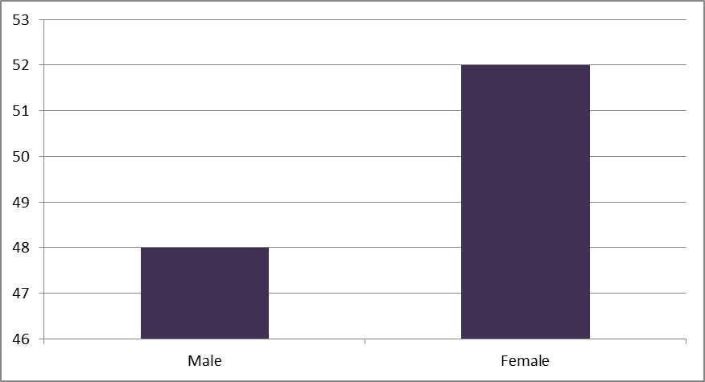

How Frequently Do You Purchase Online? (%)

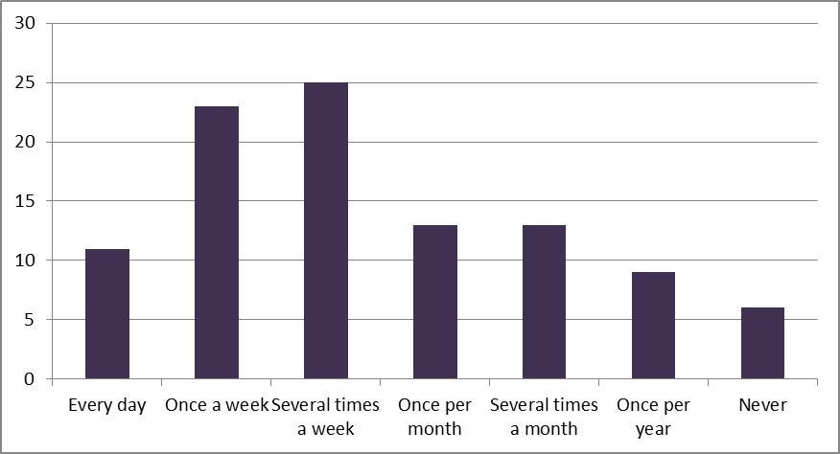

Have You Ever Bought a Car Using the Internet? (%)

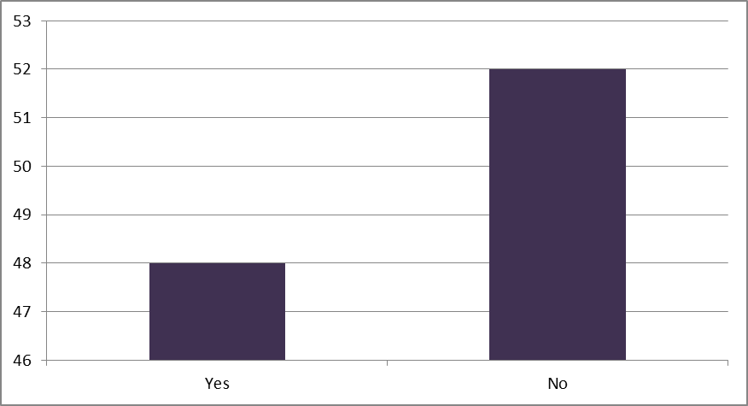

I Have Started Purchasing Online More Frequently Lately (%)

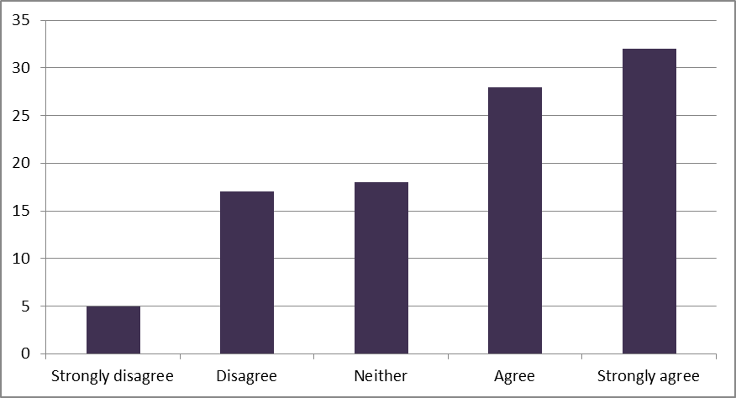

I Have Started Using the Internet to Search for Car-Related Information More Actively Lately (%)

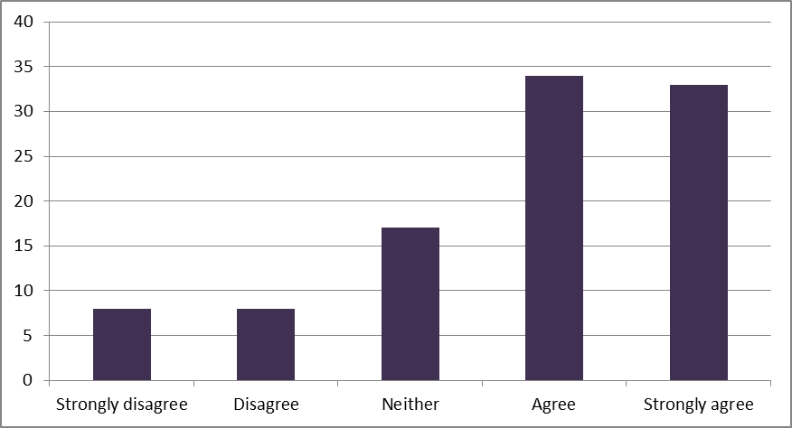

Appendix C

**Interview Responses**

***Interviewee 1:***

**Why do you prefer to shop online?**

More accessible, can do it from car, office. Anytime, anywhere. It is always available and secure.

**Why do you use the internet to search for car-related information?**

Because it is really easy to search for it, you can find review from clients and users feedbacks on the cars. Pictures, videos, and get all the information you need without going to a showroom.

**Why do you think the convenience of shopping online is high?**

Because it is accessible, can scroll through it. Do not have to go by car for any reason. Can purchase dresses and clothes, and look at them on the models.

**Why is shopping online exciting to you?**

Because they have too much offers. Considering the environment, it is very good. We are saving the environment from pollution by not consuming the cars. Convenient, and waiting for your package to come is very exciting.

***Interviewee 2:***

**Why do you prefer to shop online?**

Saves times, I can get all information I need with just one click. Not wasting time going to the store, can choose all that I want from right there.

**Why do you use the internet to search for car-related information?**

I can find all the brands I may be interested in. Rather than going to each dealer and obtaining the information I need. I can get all the information from one screen for comparison.

**Why do you think the convenience of shopping online is high?**

You can do on the spot, because you can make the research on the brands you want, on the spot.

**Why is shopping online exciting to you?**

I can catch the whole world in the minute. No need to go to sales person, and ask him a lot of questions to get the information I want. I prefer to read about it and see, in order to take the action, and make my decision right then and there.

***Interviewee 3:***

**Why do you prefer to shop online?**

It is convenient, and saves a lot of time. Time is very important to us. If you go online you can get all the information you need.

**Why do you use the internet to search for car-related information?**

Basic necessity for humans to do it now. Even if we are not certain of specific information we can always schedule an appointment to meet the sales person.

**Why do you think the convenience of shopping online is high?**

Because you can do it freely, break time, lunch time, out of office.

**Why is shopping online exciting to you?**

Because there is a lot of information you can obtain from it. The details you obtain are exciting.

***Interviewee 4:***

**Why do you prefer to shop online?**

I prefer not to shop online.

**Why do you use the internet to search for car-related information?**

Sometimes I use it. To know what I want, so I can go see it myself.

**Why do you think the convenience of shopping online is high?**

I disagree it should not be high, because it is easier to fool me online then in person. So not safe.

**Why is shopping online exciting to you?**

Online shopping is not exciting to me.

***Interviewee 5:***

**Why do you prefer to shop online?**

Having to go to the store is troubling and time consuming. I am not a big online shopper, but if I did, it would be because I am incredible lazy. In times where I do shop online, it is because I can’t find what I want in store, so I have to result to the internet.

**Why do you use the internet to search for car-related information?**

You get all the information you need, to be able to conduct a comparison of the different vehicles you like. You are saving time by not having to visit each dealer. This way you have narrowed you options down to what you need, to make the quick stops at the dealership.

**Why do you think the convenience of shopping online is high?**

These generations are quiet lazy, and honestly a lot of business are now evolving online. So a lot of sales and items we want or are interested are usually sold online more than they are in stores.

**Why is shopping online exciting to you?**

Honestly, picking out what you want. And the anticipation of waiting for it to come in, that is most exciting to me.

***Interviewee 6:***

**Do online car retailers provide you a sufficient level of security?**

Not on all home pages. I cannot know which home page is secure or not.

**Do you have considerable experience in buying online?**

Yes, I try to buy many things on the internet, and it was an OK experience. I did not have any problems. But I hear many problems from others.

**What kind of things did you buy online?**

Software and Antivirus programs, apple store items.

**Is online shopping pleasant and exciting to you?**

Yes. I buy a lot of travel tickets and hotel bookings. So I enjoy it for travel use. I can do it when I am waiting for my friends in my car, or when I wake up in the morning. Going to the store wastes our time too much.

**Have you started buying online more frequently lately? Why?**

Yes. Because now we can purchase anything we want through our smart phones, not just through our laptops from home or work. I can rent cars on my phone, and making things easier.

***Interviewee 7:***

**Do online car retailers provide you a sufficient level of security? Why?**

They do. I have never bought a car from a retailer. But I trust their ratings. Depending on the country itself.

**Do you have considerable experience in buying online? Why?**

I have no objection about purchasing what I have been buying online.

**What kind of things did you buy online?**

Brand items.

**Is online shopping pleasant and exciting to you?**

Yes, depends on what I am buying. I do prefer trying things in person, but it all depends on what I am buying.

**Have you started buying online more frequently lately? Why?**

Yes. Because everything I need comes from the states (I do not live in the states). But it also depends on the country you are in. For example Peru, I cannot ship much of anything so purchasing online wasn’t good.

***Interviewee 8:***

**Do online car retailers provide you a sufficient level of security? Why?**

I disagree; you cannot guarantee the transaction happening between the sales person and buyer. If it is a professional company there are other thoughts about that. Companies that come talk to you through online are not secure.

**Do you have considerable experience in buying online? Why?**

Depends on the company itself, if it is secure and known worldwide. Then I will understand and read about it, and do my experience in purchasing the car.

**Is online shopping pleasant and exciting to you?**

I agree, for example if you live in a country that doesn’t have the stuff I need like the states has. It is easier for you to go online and buy things from there.

**Have you started buying online more frequently lately? Why?**

Honestly, depends on the deals. Better deals, more offers. With more options I would buy online frequently.

***Interviewee 9:***

**Why do you prefer to shop online more?**

Safer, it give us time to do everything. I don’t know, but mostly people do that now.

**Why do you use the Internet to search car related information?**

To know how people think, the information is different from page to page.

**Why do you think the convince of shopping online is high?**

I think everything will be online in the future.

**Why is shopping online is exciting for you?**

It has to do with communication. The way how it is easy, people like easy. Because we can find things online, that we cannot find in other shops. So many options.

***Interviewee 10:***

**Why do you prefer to shop online more?**

It is more convenient than going to a store. Now I buy everything online, from cigarettes all the way to cars and boats. However if you don’t know the right websites to buy from, you can get cheated on and lose a lot of money for nothing.

**Why do you use the Internet to search car related information?**

I call internet the world’s end, you can write anything about cars and it will give you info in details. Sometimes I see people fighting over which car is faster, I type it online and within seconds I show them the answer.

**Why do you think the convince of shopping online is high?**

As I said before, I can do it before I go to sleep when I am in bed, when I wake up, when I am in a boring meeting, when my car is breaking down, anytime.

**Why is shopping online is exciting for you?**

Because for an example I can buy Japanese products while I am in the US, or vice versa. I can read other’s reviews and other useful tips. Sometimes I go to buy video games, and the worker does not know every genre of games to ask him, however online there are reviews about every game.